How to Initialize a Node.js Project

1. Open Command Prompt.  
   
2. Enter “cd” followed by the folder you want to create the file in.
3. Enter “npm init” to initialize.  
   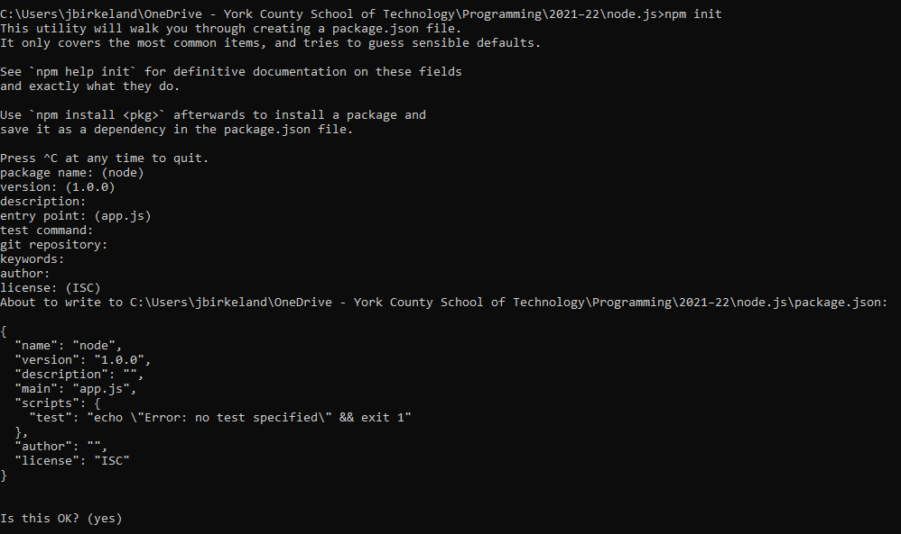A file called “package.json” is created.These are the properties of the file: 

How to Create a HTTP Server in Node.js

1. Create a new file titled “app.js”
2. Load the http module:

const http = require('http');

1. Define hostname and port:

const hostname = '127.0.0.1';

const port = 3000;

1. Display a message when someone connects:

const server = http.createServer((req, res) => {

res.statusCode = 200;

res.setHeader('Content-Type', 'text/plain');

res.end('message');

});

1. Create a listener:

server.listen(port, hostname, () => {

console.log('listening');

});

1. In the command prompt, go to the correct folder with cd, then enter the following to run:

node app.js

1. Go to this URL in your browser:

locathost:3000